The Truman Show Setting
Constructions of Reality
After we have been watching the film for a while we can easily recognise which world we are seeing. This is not only because we have become familiar with the characters which populate each world but also because we have become aware of the conventions of style within each world. The most easily recognisable features of the world of Seahaven are the sets and costumes.
SETS
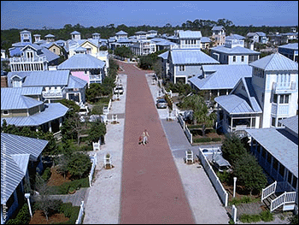
Peter Weir, the film’s director, initially thought of using Los Angeles studio backlots to create the town of Seahaven from scratch, however he considered, “The town needed a feeling of having been purpose-built, and built all at one time as with any television or movie set.”
The actual town used in the film is Seaside, a 90 acre planned community in northwest Florida USA, founded in 1980. Comprised of over 300 cottages, it is used by all-year-round residents and guests on vacation. Seaside features its own local post office, art galleries, antique shops, boutiques, bookshops and restaurants all within walking distance of each house. The residents of the community all conform to a specific building code to create the ‘storybook’ cottages they live in, and each of Seaside’s streets leads to the ocean. “It looked like it had been built for our show. I knew we could enhance it to create the ideal setting for Seahaven,” notes Peter Weir.

LIGHTING AND COLOUR
The director of photography uses different lighting effects to film each of the three stories in The Truman Show. He films scenes in Seahaven in bright sunshine with bright colours. Christof’s scenes are filmed in darker colours and shadows. The scenes of the viewers watching the Truman serial seem to be filmed in more natural light and colours.
- The colour white and bright light generally suggest purity or innocence. Does its use by Weir in Seahaven suggest that other attitudes are implied to the audience?
- What do the darker tones and colours of Christof and his studio team inside their moon suggest about them?
COSTUMES and SET DESIGN
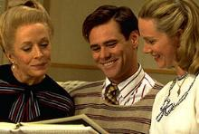
Wendy Stites, the film’s visual consultant, took her inspiration for the costumes from a variety of sources including Norman Rockwell paintings, Jean Cocteau, a book containing ‘Everyday Fashions of the 1940s’, the Saturday Evening Post magazines and photographs of the actor James Stewart. Working with costume designer Marilyn Matthews, Wendy set out to create clothing to reflect Truman’s world. Marilyn Matthews says, “Our challenge was to avoid making the costumes too cartoonish and also not to make them too tied into a specific period of time.”
With this in mind Wendy and Marilyn avoided colours such as lime green and orange - which would have given the film a contemporary feel. They concentrated on using colours such as red, black, yellow and checked patterns, and rather than buying or finding ready-made garments, the costumes for the film were made to order. Wendy Stites says, “Truman Burbank is the only person on ‘The Truman Show’ that dresses himself- the others are all dressed by the wardrobe department of the television show - so I wanted his look to be a bit different, not quite as polished.”
Peter Weir says, “I always thought of the film as taking place twenty years or so in the future, and that Christof the show’s creator would have created an idealised environment for Seahaven based on elements from the past that he particularly admired.”
- What elements from the past can you identify in the film?
- In what ways does Seahaven look like a storybook town?
- Would you like to live in Seaside (the real town)? Explain your answer.
- In what ways might the costumes be perceived as ‘cartoonish’?
- Do you think Truman’s costumes are different from the others? In what ways?
- How do the costumes reflect the personalities of the people within the community of Seahaven?

There is another constructed world within the film 'The Truman Show'; that of the production centre and the audience watching the television series.
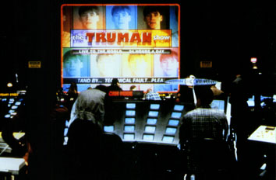
- Examine the image of the production centre. What sort of world is implied by the costume and set design? From where do you think it takes its inspiration? Does this confirm Peter Weir's vision of the film? How?
- How does this contrast with the world of Seahaven and the 'real' world of the television audience? What sets and costumes do we see from the world of the television audience?

